Beacon App

This project has been made for the Beacon organization which is based in Connecticut State, USA. This organization helps parents of children with mental disabilities to find support for relevant information about benefits, government policies, and other resources. However, this information is frequently scattered across various sources, not readily available in an organized format, and often not accessible to non-English speakers. These parents need a user-friendly platform where they can obtain accurate and timely information in their native language through simple voice interactions.

**Beacon Services of Connecticut (Beacon)** is a private group practice of behavior analysts and multidisciplinary early intervention professionals organized to provide therapeutic services to individuals with developmental disabilities. The 0 to 3 program by Beacon Health Options focuses on early childhood development and support for families with young children.

* ****Early Childhood Mental Health Consultation****: Beacon offers consultation services to support parents, caregivers, and early childhood educators in understanding and managing the emotional and behavioral needs of children aged 0 to 3 years.
* ****Parenting Support and Education:**** They provide resources and guidance to parents and caregivers on topics such as child development, nurturing healthy attachments, and managing challenging behaviors in young children.
* ****Screening and Assessment:**** Beacon conducts screenings and assessments to identify early signs of developmental delays, behavioral concerns, or mental health issues in infants and toddlers.
* ****Referral and Coordination of Services****: They assist families in connecting with appropriate community resources, including pediatricians, therapists, early intervention programs, and other support services as needed.
* ****Training and Workshops:**** Beacon offers training sessions and workshops for professionals working with young children to enhance their understanding of early childhood mental health and effective intervention strategies.
* ****Support for High-Risk Populations:**** They provide targeted support for families facing additional challenges such as poverty, trauma, or other adverse circumstances that may impact early childhood development.
* ****Collaboration with Early Childhood Programs:**** Beacon collaborates with early childhood programs, childcare centers, and preschools to promote a supportive environment that fosters healthy development in young children.

**Challenges:**

Some of the primary challenges faced by Analysts and Therapists at Beacon include:

* Lack of a central knowledge repository for the Parents who wish to learn about the available resources such as:
  + Diapers and food
  + Child Assessment and therapies
  + Pediatric consultation
  + Transportation to and from the Pediatrician
* Language barriers: Many parents do not speak English, making communication difficult without a translator.
* Difficulty in Tracking Children's Progress
  + Reliance on manual paperwork during therapy and counseling sessions
  + Challenges in reporting children's progress to the state
  + No system for parents to access and understand their child's progress
* Lack of Preliminary Self-Assessment Tools: Parents lack the means to perform preliminary self-assessments of their children to identify symptoms and determine how and where to seek help.

**Possible solutions:**

Based on our initial discussion and the information shared by the Analysts and the Social workers of Beacon, we anticipate the following preliminary solutions. Please note that these are high-level ideas and should not be considered final:

*Voice-Based Interaction for Parents:*

* Enable parents to interact with an app on their phone to receive information about available resources.
* Provide voice-based interaction in the language of their choice.

*Note-Taking Capability for Therapists:*

* Allow therapists to take notes and store information during their sessions with the child, which can be used to:
  + Quantitatively assess the child's progress.
  + Enable parents to monitor their child's progress.
  + Allow Beacon to report the child's progress to the State in a quantitative manner.

*Initial Self-Assessment Tool for Parents:*

* Provide parents with the ability to perform an initial self-assessment of their child to:
* Identify symptoms.
* Understand their rights and available options.
* Seek help for their child.

Objective: To develop a web application that provides accessible information about benefits programs , government policies and other resources for parents of children with mental disabilities. This application will allow parents to ask questions in their native language (primarily Spanish) , process the speech to provide accurate and helpful responses, and deliver the information in the same language.

Tools and Technologies Used:

* Google Cloud Speech-to-Text API
* Google Cloud Translation API
* Vertex AI Search API
* Cloud Run
* Cloud SQL
* LLM Model: Gemini 1.5 flash
* Google Places API
* Fast Api for creating backend
* React native CLI tool
* React native components

Key Functionality of App

* Register: New user registration from email, mobile and address.
* Login: User can login with email/mobile
* Start new conversation asking information about policies, resources in English or Spanish.
* Profile editing feature and child adding option are also provided.
* Users can change the password when required.
* Conversation History: User can view conversation done previously.

Grounding in Vertex AI

In generative AI, grounding is the ability to connect model output to verifiable sources of information. If you provide models with access to specific data sources, then grounding tethers their output to these data and reduces the chances of inventing content. This is particularly important in situations where accuracy and reliability are significant.

Grounding provides the following benefits:

* Reduces model hallucinations, which are instances where the model generates content that isn't factual.
* Anchors model responses to specific information.
* Enhances the trustworthiness and applicability of the generated content.

**Why Grounding?**

1) In our case, the primary objective is to provide the user with the most updated information or resources or aid available in his location.

2) Also, it makes our model more accurate and reliable.

3) We would not need to depend on the client for the data.

4) Cost of web scraping jobs (get and post cloud run functions) on GCP as well as cloud storage(for jsons) cost will be saved.

Architecture Diagram:

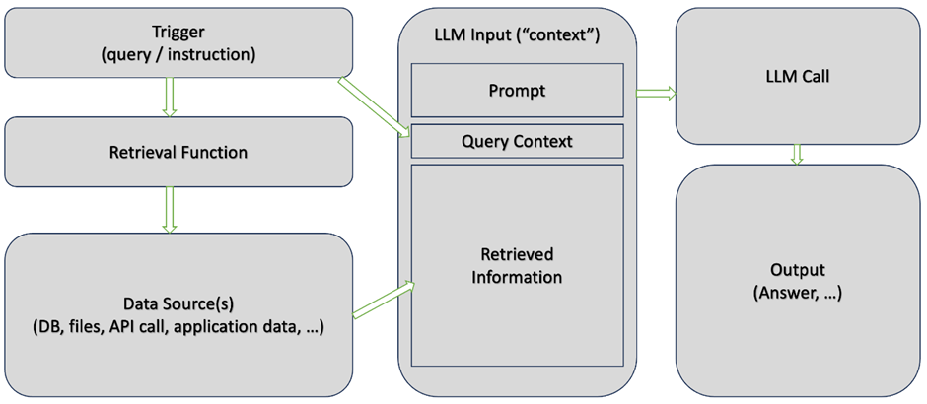

Backend Services

We have used GCP to deploy our backend services on cloud run as unauthenticated, but we have secured it with jwt token authorization. We have listed down the detailed approach below.

JWT Approach Workflow

1. User Registration (/register endpoint)

* This endpoint takes a UserCreate object and checks if the email already exists.
* If the user doesn’t exist, it hashes the user’s password with passlib.context.CryptContext .
* The hashed password and user details are then inserted into the Users table.
* The bcrypt hashing algorithm, as used in the code with CryptContext, is safe and suitable for storing passwords because it is designed to be *one-way* and *non-reversible*. Here's how bcrypt ensures security and prevents decryption:
* **One-Way Hashing**: bcrypt is a hashing algorithm, meaning it generates a hash from an input (like a password) but cannot directly retrieve the original input from the hash. The hash itself is a "fingerprint" of the input data but is not reversible.
* **Salting**: bcrypt automatically generates a unique salt each time a password is hashed. This salt is stored with the hash and ensures that even if two users have the same password, their hashes will differ due to the unique salt.
* **Work Factor**: bcrypt includes a work factor (or cost factor), which determines the computational complexity of hashing. By increasing this factor, we can make it significantly more time-consuming to attempt brute-force attacks. This work factor can be adjusted over time to keep up with advances in computational power.
* **Password Verification**: Instead of decrypting, the process of checking a password involves hashing the input password with the same salt and comparing it to the stored hash. If they match, it verifies the password without ever needing to "decrypt" it.

1. User Login (/signin endpoint)

* This endpoint accepts either an email or mobile number for authentication.
* authenticate_user checks if the email or mobile exists in the database. If not, it returns None, indicating invalid credentials.
* If a user is found, it verifies the password using passlib.
* On successful authentication, it checks if the is_delete flag is set to 1. If it is, login is prevented, meaning the user is soft-deleted and cannot access the system.
* If the user is valid, the create_access_token function generates a JWT token for them, allowing authenticated access.

Code snippet for authenticate_user

def authenticate_user(email_or_mobile: str, password: str):

# Query the database for the user by email or mobile

query = f"SELECT email, mobile, password FROM Users WHERE email = '{email_or_mobile}' OR mobile = '{email_or_mobile}'"

result = execute_sql_query(query)

# If the user does not exist, return None

if len(result) == 0:

return None

# Extract the stored password hash

stored_password_hash = result[0][2] # The third column (index 2) contains the password

# Verify the password

if not pwd_context.verify(password, stored_password_hash):

return None

# Return the user information (you can modify this based on what you want to return)

return result[0][:2] # Return both email and mobile

Code snippet for create_access_token

def create_access_token(data: dict, expires_delta: timedelta = None):

to_encode = data.copy()

if expires_delta:

expire = datetime.now(timezone.utc) + expires_delta

else:

expire = datetime.now(timezone.utc) + timedelta(minutes=1440)

to_encode.update({"exp": expire})

encoded_jwt = jwt.encode(to_encode, SECRET_KEY, algorithm=ALGORITHM)

return encoded_jwt

1. **Creating the JWT Token (create_access_token function)**:

* **Payload Data**: A dictionary containing user-specific data is passed as data.
* **Expiration**: By default, it sets an expiration time of 24 hours (1440 minutes).
* **Encoding**: It uses the jwt.encode function, applying the HS256 algorithm and a SECRET_KEY to create a signed token.
* **Token**: The generated JWT token is returned to the client for future use.

#### **JWT Token Validation and Dependency Injection**

* **Token Validation** (get_current_user function):
  + This function decodes the JWT token using jwt.decode with the SECRET_KEY and algorithm HS256.
  + **Token Data Extraction**: If the token is valid, it extracts the username from the token payload.
  + **Error Handling**: If the token has expired (ExpiredSignatureError) or is otherwise invalid (InvalidTokenError), it raises HTTP_401_UNAUTHORIZED.
  + **Dependency Injection**: This function is used as a Depends dependency in any endpoint that requires authentication by adding it as a parameter (token: str = Depends(oauth2_scheme)).

Code snippet for get_current_user

def get_current_user(token: str = Depends(oauth2_scheme)):

try:

payload = jwt.decode(token, SECRET_KEY, algorithms=[ALGORITHM])

username: str = payload.get("sub")

if username is None:

raise HTTPException(

status_code=status.HTTP_401_UNAUTHORIZED,

detail="Invalid authentication credentials",

headers={"WWW-Authenticate": "Bearer"},

)

return username

except jwt.ExpiredSignatureError:

raise HTTPException(

status_code=status.HTTP_401_UNAUTHORIZED,

detail="Token expired",

headers={"WWW-Authenticate": "Bearer"},

)

except jwt.InvalidTokenError:

raise HTTPException(

status_code=status.HTTP_401_UNAUTHORIZED,

detail="Invalid token",

headers={"WWW-Authenticate": "Bearer"},

)

1. **OAuth2 Password Flow**:

* OAuth2PasswordBearer is instantiated with tokenUrl="signin", enabling OAuth2 password flow.
* This means that when a user logs in, they receive a JWT token. Subsequent requests to protected endpoints require this token in the Authorization header as a Bearer token.

oauth2_scheme = OAuth2PasswordBearer(tokenUrl="signin")

1. Summary of entire process

* **Token Issuance**: On login, create_access_token generates a JWT token containing user details and an expiration time.
* **Token Verification**: get_current_user checks the validity of the token. If valid, it allows access; if expired or invalid, it denies access.
* **Protected Access**: Only endpoints with Depends(get_current_user) can be accessed by authenticated users.

Example Usage of JWT Token in Protected Endpoints:

To secure an endpoint, we have added token: str = Depends(oauth2_scheme) as a parameter in any FastAPI route:

@app.post("/chat")

async def store_chat_message(chat_message: ChatMessageInitiation,current_user: str = Depends(get_current_user)):

email = chat_message.username # Get the email from the request payload

This approach provides secure, token-based authentication and authorization with JWT, ensuring that only authenticated users can access protected resources.

**Grounding Technqiue used to improve the performance of Beacon Chatbot**

* Using the latest **LLM Grounding technique** to handle all the user queries.

**What is Grounding?**

In generative AI, grounding is the ability to connect model output to verifiable sources of information. If you provide models with access to specific data sources, then grounding tethers their output to these data and reduces the chances of inventing content. This is particularly important in situations where accuracy and reliability are significant.

Grounding provides the following benefits:

* Reduces model hallucinations, which are instances where the model generates content that isn't factual.
* Anchors model responses to specific information.
* Enhances the trustworthiness and applicability of the generated content.

**Grounding with Google Search**

When we use Grounding with Google Search, it links the Gemini model to the internet.

|  |  |
| --- | --- |
| Ungrounded Gemini | Grounded Gemini |
| **Prompt:** Food Distribution timing in Mansfield today?  **Response:** I do not have access to real-time information, including constantly updating schedules for food distribution centers. Therefore, I can't definitively tell you the food distribution timing in Mansfield (presumably Mansfield, CT) *today*. However, here's how you can find that information:   1. Contact Mansfield Social Services: They are the primary point of contact for local assistance programs and can provide you with the most accurate information about food distribution schedules in Mansfield. You can find their contact information on the town of Mansfield's official website. 2. Call 211 (United Way): Dialing 211 connects you to a resource specialist who can provide information on various social services, including food pantries and meal programs in your area. They often have the most current schedules. 3. Check with Local Churches and Charities: Many churches and charities operate independent food pantries. Contacting churches in Mansfield directly may yield additional distribution sites and times. 4. Search Online: Use search terms like "food pantries in Mansfield CT" or "food banks near me" to locate organizations that may offer food assistance. Look for official websites or social media pages for the most up-to-date details.   By utilizing these methods, you'll be able to find the most current and accurate food distribution timing in Mansfield for today. | **Prompt**: Food Distribution timing in Mansfield today?  **Response:** Here are the food distribution timings for various locations in Mansfield, TX today, October 18, 2024. Please note this information is based on the data available today and may be subject to change. It is always best to call ahead to confirm hours and any specific requirements.   * HIM Center: Grocery appointments are available Monday, Tuesday, Thursday, and Friday from 9:00 am to 3:00 pm.[[1](https://www.google.com/url?sa=E&q=https%3A%2F%2Fvertexaisearch.cloud.google.com%2Fgrounding-api-redirect%2FAWhgh4xeRVtxgpKK-QhbmXLfzB9RQ4JhR8D0Mv5NYRNNP0_oSXYgX7MJqur-Ux4rtcCrVJgc-atSIo18GrpQnU3Mp_gRxse7wel3aQ0r2374pX4p-MlDWLmhJHmerCrbv3rE)] Note: Today is Friday, so they *should* be open, but their website has some contradictory information about Friday hours. It's highly recommended to call (817) 453-3663 to confirm before going. They are not open for grocery appointments on Wednesdays. * Mansfield Food Pantry: Open today (Friday) from 9 am - 11 am (drop-in). They also offer distributions on Thursdays by appointment only (10 am - 12 pm and 5 pm - 7 pm).[[2](https://www.google.com/url?sa=E&q=https%3A%2F%2Fvertexaisearch.cloud.google.com%2Fgrounding-api-redirect%2FAWhgh4yAbMJSiwSJGQXeruS53NHF9MztQlybx5brWWxKlhiLZ-XFYVoLkD53J8zFNhXnfenZoUvP5NdVTQM3rhpxQfOLTh_b93VJ-AGvHxo7GqPDySyk12JJhSxFvFk_vlgQ)] * Grace Episcopal Church: Their pantry is open Thursday mornings from 9 am to 11 am and on the 2nd and 4th Wednesday evenings from 4 pm to 6 pm.[[4](https://www.google.com/url?sa=E&q=https%3A%2F%2Fvertexaisearch.cloud.google.com%2Fgrounding-api-redirect%2FAWhgh4zk1q5cZSQjIj4OGI4H8xY9kFcopnLG_41_hT3TJP_H0r790zGmoz_dF36uNqzG7V1v7iWtUHMRkE46uvpPVqb3yVuwkKXVzD7UK28aahcpqneCuzB7u13DgJeD0g3ZKgcy)] This means they are *not* open today, Friday, October 18th. * Wesley Mission Center: Their food pantry is open today, Friday, from 10 am to 2 pm. This is open to anyone in need of food assistance, regardless of where you live.[[3](https://www.google.com/url?sa=E&q=https%3A%2F%2Fvertexaisearch.cloud.google.com%2Fgrounding-api-redirect%2FAWhgh4yqz4Hi2BB2mh7Cla0D7G-xpaJhXYfDUUy0JkwGl-e2D0BN18HX5ihYNnx26EMb3hA_sUvJc-U_BEDiRM0fMkhK5cRDgw8NoMciNwAoVTHEnJ-uKNp3Otjkh4jYMk7NePBYnWOU4mNpoAuq)] Remember to bring a photo ID and proof of address.[[3](https://www.google.com/url?sa=E&q=https%3A%2F%2Fvertexaisearch.cloud.google.com%2Fgrounding-api-redirect%2FAWhgh4yqz4Hi2BB2mh7Cla0D7G-xpaJhXYfDUUy0JkwGl-e2D0BN18HX5ihYNnx26EMb3hA_sUvJc-U_BEDiRM0fMkhK5cRDgw8NoMciNwAoVTHEnJ-uKNp3Otjkh4jYMk7NePBYnWOU4mNpoAuq)] They also offer food assistance through their C.A.R.E program by appointment, specifically for Mansfield ISD residents.   It's worth noting that some food pantries require pre-registration or appointments, while others operate on a drop-in basis. Eligibility requirements might also vary, so it's crucial to confirm the details with each organization before going.  Grounding Sources   1. [himcenter.org](https://vertexaisearch.cloud.google.com/grounding-api-redirect/AWhgh4xeRVtxgpKK-QhbmXLfzB9RQ4JhR8D0Mv5NYRNNP0_oSXYgX7MJqur-Ux4rtcCrVJgc-atSIo18GrpQnU3Mp_gRxse7wel3aQ0r2374pX4p-MlDWLmhJHmerCrbv3rE) 2. [mansfieldfoodpantry.org](https://vertexaisearch.cloud.google.com/grounding-api-redirect/AWhgh4yAbMJSiwSJGQXeruS53NHF9MztQlybx5brWWxKlhiLZ-XFYVoLkD53J8zFNhXnfenZoUvP5NdVTQM3rhpxQfOLTh_b93VJ-AGvHxo7GqPDySyk12JJhSxFvFk_vlgQ) 3. [wesleymissioncenter.org](https://vertexaisearch.cloud.google.com/grounding-api-redirect/AWhgh4yqz4Hi2BB2mh7Cla0D7G-xpaJhXYfDUUy0JkwGl-e2D0BN18HX5ihYNnx26EMb3hA_sUvJc-U_BEDiRM0fMkhK5cRDgw8NoMciNwAoVTHEnJ-uKNp3Otjkh4jYMk7NePBYnWOU4mNpoAuq) 4. [gracemansfield.org](https://vertexaisearch.cloud.google.com/grounding-api-redirect/AWhgh4zk1q5cZSQjIj4OGI4H8xY9kFcopnLG_41_hT3TJP_H0r790zGmoz_dF36uNqzG7V1v7iWtUHMRkE46uvpPVqb3yVuwkKXVzD7UK28aahcpqneCuzB7u13DgJeD0g3ZKgcy) |

Summary: We can see that grounding exposes the model to real time information and there is no need to maintain outdated information in our knowledge base.

**Why Grounding?**

1) In our case, the primary objective is to provide the user with the most updated information or resources or aid available in his location.

2) Also, it makes our model more accurate and reliable.

3) We would not need to depend on the client for the data.

4) Cost of web scraping jobs (get and post cloud run functions) on GCP as well as cloud storage(for jsons) cost will be saved.

Architecture Diagram:

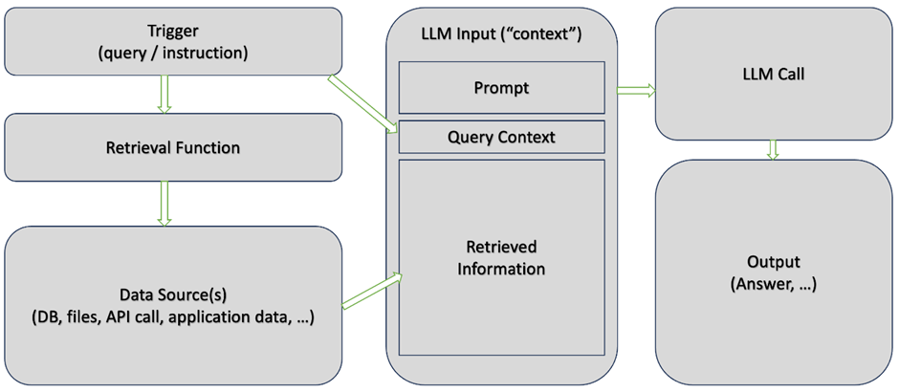

Here, the data source(s) will be provided by the google web search api.

Few more examples with grounding:

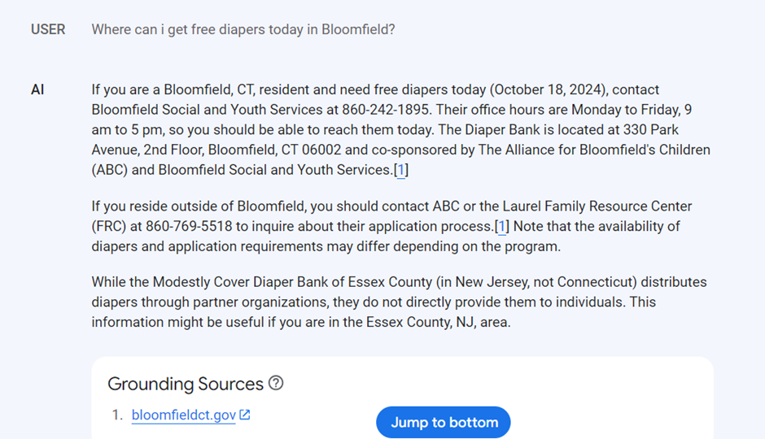

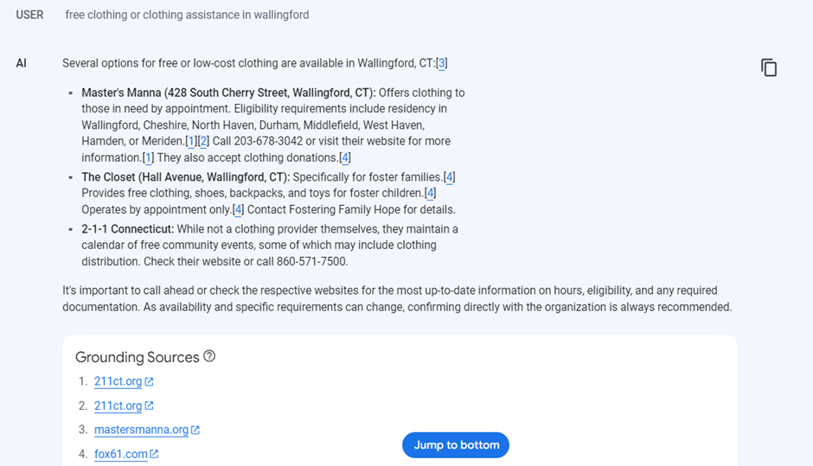

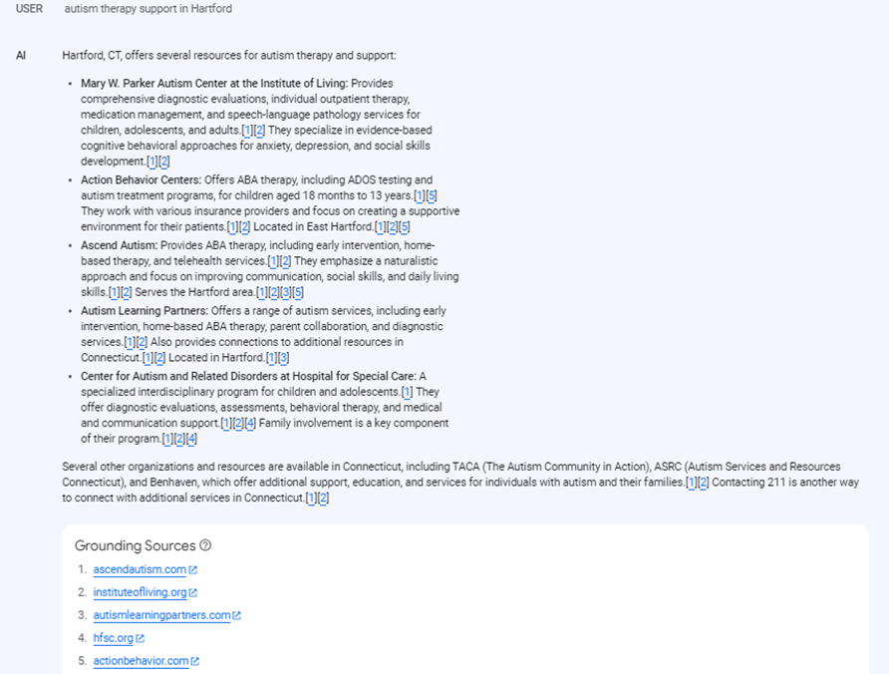

The Following Code is used to implement grounding in the beacon chatbot/application:

from typing import Tuple, Optional

import re

from datetime import datetime

import os

from fastapi import FastAPI, HTTPException, Request

from pydantic import BaseModel

from google.api_core.client_options import ClientOptions

from google.cloud import discoveryengine_v1 as discoveryengine

import os

import uuid

import json

import datetime

os.environ['GOOGLE_APPLICATION_CREDENTIALS'] = 'sixth-module-394805-ea74c74abf71.json'

project_id = "sixth-module-394805"

location = "global"

engine_id = "beacon-app4_1729704572786"

#os.environ['GOOGLE_APPLICATION_CREDENTIALS']="my_service_account.json"

#from google.cloud.sql.connector import Connector, IPTypes

import pymysql

import sqlalchemy

from google.cloud.sql.connector import Connector

from sqlalchemy import text

db_details={

'db_user':'USER_rw',

'db_pass':'Ct3pl@123',

'db_name':'beacon_chatbot'

}

connector=Connector()

connection = "sixth-module-394805:us-central1:beacon-chatbot"

#ip_type = IPTypes.PRIVATE if os.environ.get("PRIVATE_IP") else IPTypes.PUBLIC

#connector = Connector(ip_type)

# Data models for request bodies

class ChatRequest(BaseModel):

user_id: str

query: str

class ClearSessionRequest(BaseModel):

user_id: str

def get_or_create_session(user_id: str) -> str:

"""Get existing session or create a new one for a specific user."""

sessions_file = 'user_sessions.json'

# Load existing sessions

if os.path.exists(sessions_file):

with open(sessions_file, 'r') as f:

sessions_data = json.load(f)

else:

sessions_data = {}

# Check if user already has a session

if user_id in sessions_data:

return sessions_data[user_id]['session_name']

# Create new session for user

client = discoveryengine.ConversationalSearchServiceClient()

user_pseudo_id = str(uuid.uuid4())

session = client.create_session(

parent=f"projects/{project_id}/locations/{location}/collections/default_collection/engines/{engine_id}",

session=discoveryengine.Session(user_pseudo_id=user_pseudo_id),

)

session_name = str(session.name)

# Save session data

sessions_data[user_id] = {

'session_name': session_name,

'created_at': str(datetime.datetime.now())

}

with open(sessions_file, 'w') as f:

json.dump(sessions_data, f)

return session_name

def getconn() -> pymysql.connections.Connection:

conn: pymysql.connections.Connection = connector.connect(

connection,

"pymysql",

user=db_details['db_user'],

password=db_details['db_pass'],

db=db_details['db_name']

)

return conn

sql_engine = sqlalchemy.create_engine(

"mysql+pymysql://",

creator=getconn,

)

def execute_sql_query(query):

with sql_engine.connect() as connection:

result = connection.execute(text(query))

# If it's a SELECT query, return the result directly

if query.strip().upper().startswith("SELECT"):

result_data = result.fetchall() # Fetch all rows

sql_engine.dispose()

return result_data

# For INSERT/UPDATE/DELETE queries, commit the transaction

connection.commit()

sql_engine.dispose()

return result.lastrowid

#query = f"SELECT name, dob FROM child WHERE parent_id =22"

#result=execute_sql_query(query)

#print(result[0][1])

#child_name=result[0][0] #str

#child_dob=result[0][1] #datetime.date

def get_child_info(user_id: str) -> Optional[Tuple[str, int]]:

"""

Fetch child information from database for given user_id.

Returns tuple of (child_name, age_in_years) if found, None otherwise.

"""

try:

print("inside get child info")

# Assuming you have a database connection and Child table

query = f"SELECT name, dob FROM child WHERE parent_id ={user_id}"

result=execute_sql_query(query)

if result:

child_name=result[0][0] #str

child_dob=result[0][1] #datetime.date

# Calculate age

today = datetime.datetime.now()

age = today.year - child_dob.year - ((today.month, today.day) < (child_dob.month, child_dob.day))

return (child_name, age)

return None

except Exception as e:

print(f"Error fetching child info: {e}")

return None

def is_child_related_query(query_text: str) -> bool:

"""

Check if the query is related to children using keyword matching.

"""

child_keywords = {

'child', 'kid', 'baby', 'toddler', 'infant', 'children',

'daughter', 'son', 'childhood', 'pediatric', 'child\'s',

'kids', 'babies', 'youngster', 'little one'

}

# Convert query to lowercase and create word set

query_words = set(re.findall(r'\w+', query_text.lower()))

# Check if any child-related keyword exists in query

return bool(query_words & child_keywords)

def enhance_query_with_child_context(query_text: str, child_name: str, age: int) -> str:

"""

Enhance the query by adding child context in a natural way.

"""

# Add context based on query type

context = f" Consider that this question is about a {age}-year-old child named {child_name}."

# Special handling for different types of queries

if "development" in query_text.lower() or "milestone" in query_text.lower():

context = f" For a {age}-year-old child named {child_name}, regarding their development:"

elif "nutrition" in query_text.lower() or "food" in query_text.lower() or "eat" in query_text.lower():

context = f" Considering this is for {child_name}, who is {age} years old:"

elif "activity" in query_text.lower() or "play" in query_text.lower():

context = f" For activities suitable for {child_name}, who is {age} years old:"

return query_text + context

def answer_query(user_id: int, query_text: str,city:str):

"""Answer a query for a specific user with child context when relevant."""

client_options = None

if location != "global":

client_options = ClientOptions(api_endpoint=f"{location}-discoveryengine.googleapis.com")

client = discoveryengine.ConversationalSearchServiceClient(

client_options=client_options

)

serving_config = f"projects/{project_id}/locations/{location}/collections/default_collection/engines/{engine_id}/servingConfigs/default_serving_config"

# Check if query is child-related and enhance if necessary

enhanced_query = query_text

if is_child_related_query(query_text):

child_info = get_child_info(user_id)

if child_info:

child_name, age = child_info

enhanced_query = enhance_query_with_child_context(query_text, child_name, age)

query_understanding_spec = discoveryengine.AnswerQueryRequest.QueryUnderstandingSpec(

query_rephraser_spec=discoveryengine.AnswerQueryRequest.QueryUnderstandingSpec.QueryRephraserSpec(

disable=False,

max_rephrase_steps=1,

),

query_classification_spec=discoveryengine.AnswerQueryRequest.QueryUnderstandingSpec.QueryClassificationSpec(

types=[

discoveryengine.AnswerQueryRequest.QueryUnderstandingSpec.QueryClassificationSpec.Type.ADVERSARIAL_QUERY,

discoveryengine.AnswerQueryRequest.QueryUnderstandingSpec.QueryClassificationSpec.Type.NON_ANSWER_SEEKING_QUERY,

]

),

)

city=city

print(city)

preamble = f"""

You are an AI assistant designed to help parents of specially abled children find local services and resources. Respond with clear, concise information based on the user's queries, drawing from your knowledge base to deliver relevant service details.

### Greeting Handling

- If the user says "Hi," "Hello," or "Hola," respond with "Hello! What can I assist you with today?"

- For all other messages, respond directly without a greeting.

### Focus on **assistance**

- **Interpret all queries for free services as requests for assistance** with that specific service. For example:

- **"free clothing"** should be treated as **"clothing assistance"**.

- **"free transportation"** should be treated as **"transportation assistance"**.

- **"free English language learner (ELL) classes"** should be treated as **"ELL assistance"**.

- **"free education and advocate"** should be treated as **"educational advocacy assistance"**.

- **"free private services"** should be treated as **"private services assistance"**.

- **"free playgroups"** should be treated as **"playgroup assistance"**.

- **"free employment"** should be treated as **"employment assistance"**.

**Key Rule:** When a user asks for **free** services, your response should focus on **assistance** related to that service, removing the emphasis on "free" and instead providing relevant support options or resources.

### Conversation Closure Rules

- If the user says "no," "nope," "no thanks," or "no thank you," respond with "Thank you! Have a great day!" and avoid follow-ups.

### Response Format

- Provide responses with hyperlinks in markdown format (`[link text](URL)`) for all relevant websites so they are clickable on mobile devices.

- Provide all your answers in a **structured format**. When a user asks for details on services, use the following sections:

- **Service Description**: A brief summary of the service.

- **Contact Information**: Provide the contact phone number, email, or website for further inquiries.

- **Location/Eligibility**: Mention the location where the service is available and any eligibility criteria for users to access it.

For example, if the user asks, **'Are there free food services near me?'**, the response should be:

**Service Description**: Provides free meal programs for individuals in need.

**Contact Information**: Phone: 555-1234, Website: [example.org](https://example.org).

**Location**: Available at local community centers; open to all, no eligibility criteria required.

- At the end of your responses,add a warm note to encourage the user to ask follow up questions pertaining to same topic.

### Special Query Handling

- Treat requests for "free formula" in the same way as "free food" for consistency.

---

### Location-Based Query Processing

1. Query Classification

- Location-Dependent Queries:

- For services like the following, provide answers based on the user's location:

1. free food

2. legal aid

3. immigration services

4. free diapers

5. housing aid

6. private services

7. education and advocates

8. playgroups

9. support and counseling

10. transportation

11. employment

12. ELL classes

13. internet or cell access

- Location-Independent Queries:

- For general queries about medical information, advice, or definitions (e.g., questions about autism symptoms or Medicaid), provide responses that are not location-based.

2. For Location-Dependent Queries

- Remember the service (e.g., "free food") mentioned by the user.

- The user’s city is given as {city}.

- If the user's city is one of the following:

- Bloomfield

- Wallingford

- Hamden

- New Britain

- Hartford

- Meriden

Use the following rules:

- Subcase 1: If information is available for the requested service in the user’s city, respond with "Here's the information about the [requested service] in [user's city]."

- Subcase 2: If information is not available for the requested service in the user’s city, respond with "I don’t have information about the requested service in [user's city]. Please let me know if I can help you with something else?"

- For cities outside the above list, respond with:

"I don’t have information about [requested service] in [user's city]. However, I do have information for the following cities: Bloomfield, Wallingford, Hamden, New Britain, Hartford, Meriden. For which city would you like to know more about this service?"

- If the user requests information for a different city among these options, provide relevant details for that city.

- If the user declines, follow any additional questions or close the conversation as appropriate.

- For follow-up queries without an explicitly mentioned city, or explicitly mentioned service, use the **last specified city** or **last specified [requested service]** present in your context for response.

### Acknowledgment Handling

- If the user replies with only **"ok"** or **"okay"**:

- Respond with: **"Thank you! Is there anything else I can assist with?"**

- If the user replies **"yes"**:

- Ask: **"How can I help you?"**

- If the user replies **"no"**:

- End the conversation with: **"Thank you! Have a great day!"**

### Important Rules Recap

1. **Classify every query** as location-dependent or location-independent.

2. If query contains phrases like "my area" "near me" "my location" etc treat it as {city}

"""

answer_generation_spec = discoveryengine.AnswerQueryRequest.AnswerGenerationSpec(

ignore_adversarial_query=False,

ignore_non_answer_seeking_query=False,

ignore_low_relevant_content=False,

model_spec=discoveryengine.AnswerQueryRequest.AnswerGenerationSpec.ModelSpec(

model_version="gemini-1.5-flash-001/answer_gen/v2",

),

prompt_spec=discoveryengine.AnswerQueryRequest.AnswerGenerationSpec.PromptSpec(

preamble=preamble,

),

include_citations=True,

answer_language_code="en",

)

session_name = get_or_create_session(user_id)

request = discoveryengine.AnswerQueryRequest(

serving_config=serving_config,

query=discoveryengine.Query(text=enhanced_query),

session=session_name,

query_understanding_spec=query_understanding_spec,

answer_generation_spec=answer_generation_spec,

)

response = client.answer_query(request)

return response.answer.answer_text

#Example usage

user_id=77

query="Autism therapy help for my son"

#query="free clothing"

city="Hamden"

#query="what is asd"

answer=answer_query(user_id,query,city)

print(answer)

COST ESTIMATE FOR THE WHOLE PROJECT ON GCP

**Cost Estimate for Mobile App Using Vertex AI and Translation API**

**1. AI Costs (Vertex AI and Translation API)**

Details of AI-related costs:

|  |  |  |
| --- | --- | --- |
| Component | Details | Cost (USD) |
| Vertex AI | Cost for generating answers using Gemini 1.5 Flash | 17.65 (per 1,000 requests) |
| Translation API | Language translation for 6.4 million characters (1,000 requests) | 128.00 |

**2. Cloud Costs (Cloud Run and Cloud SQL)**

|  |  |  |
| --- | --- | --- |
| Component | Details | Cost (USD) |
| Cloud SQL | Specifications: 2 vCPUs, 8GB Memory, 10GB SSD | 101.00 |
| Cloud Run | Operational overhead for running services | 9.00 |

**3. App Store Costs (iOS and Google Play)**

|  |  |  |
| --- | --- | --- |
| Component | Details | Cost (USD) |
| iOS Developer Account | Annual subscription cost | 99.00 (per year) |
| Google Play Store | One-time registration fee | 25.00 |

**4. Final Cost Estimate (With and Without Translation)**

|  |  |  |  |
| --- | --- | --- | --- |
| Scenario | AI Costs (USD) | Cloud Costs (USD) | Total Cost (USD) |
| With Translation | 145.65 | 110.00 | 255.65 (Assuming 1000 requests for the month) |
| Without Translation | 17.65 | 110.00 | 127.65(Assuming 1000 requests for the month) |

# **Cost Estimate for Mobile App Using Vertex AI and Translation API**

Table of Contents

1. AI Costs (Vertex AI and Translation API)
2. Cloud Costs (Cloud Run and Cloud SQL)
3. App Store Costs (iOS and Google Play)
4. Final Cost Estimate (With and Without Translation)

## **1. AI Costs (Vertex AI and Translation API)**

Details of AI-related costs:

|  |  |  |
| --- | --- | --- |
| Component | Details | Cost (USD) |
| Vertex AI | Cost for generating answers using Gemini 1.5 Flash | 17.65 (per 1,000 requests) |
| Translation API | Language translation for 6.4 million characters (1,000 requests) | 128.00 (per 1,000 requests) |

## **2. Cloud Costs (Cloud Run and Cloud SQL)**

Breakdown of cloud-related costs:

|  |  |  |
| --- | --- | --- |
| Component | Details | Cost (USD) |
| Cloud SQL | Specifications: 2 vCPUs, 8GB Memory, 10GB SSD | 101.00 per month |
| Cloud Run | Operational overhead for running services | 9.00 per month |

## **3. App Store Costs (iOS and Google Play)**

Details of app store platform-related costs:

|  |  |  |
| --- | --- | --- |
| Component | Details | Cost (USD) |
| iOS Developer Account | Annual subscription cost | 99.00 (per year) |
| Google Play Store | One-time registration fee | 25.00 |

## **4. Final Cost Estimate (With and Without Translation)**

Summary of the total costs:

|  |  |  |  |
| --- | --- | --- | --- |
| Scenario | AI Costs (USD) | Cloud Costs (USD) | Total Cost (USD) |
| With Translation | 145.65 | 110.00 | 255.65 (assuming 1000 translations for month) |
| Without Translation | 17.65 | 110.00 | 127.65 (assuming 1000 requests for month) |

**The following content contains all the information about our client – Beacon Services of Connecticut or in short “Beacon”**

--- Content from <https://www.beaconct.org/> ---

Title: Home - Beacon Services of Connecticut

URL Source: <https://www.beaconct.org/>

Markdown Content: 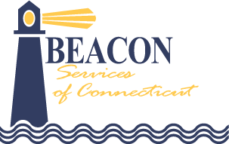

## **About Us**

Beacon Services of Connecticut (Beacon) is a private group practice of behavior analysts and multidisciplinary early intervention professionals organized to provide therapeutic services to individuals with developmental disabilities. The practice specializes in providing evidence-based treatment interventions to support children and families in reaching their highest potential. Beacon works extensively with individuals who exhibit a variety of developmental needs and challenging behaviors by building adaptive skills in homes, schools, and community settings. Beacon actively contributes to the fields of Applied Behavior Analysis (ABA) and Early Intervention (EI) through training students and professionals, contributing to field-based research, and establishing collaborative professional partnerships.



## **Programs & Services**

Beacon Services of Connecticut was established to provide critical services for children with ASD and other special needs.







## **Careers: Love Your Life’s Work!**

## **Our Executive Team**

## **Caring through Competence**

Providing Early Intervention and ABA services and making a difference to families affected by ASD and developmental delay.



Founder and CEO

Robert F. Littleton Jr. is the Founder and Chief Executive Officer of numerous service agencies including Beacon ABA Services of Massachusetts and Connecticut, the Evergreen Center, Criterion Child Enrichment, BehaviorPedia Inc., and Human Services Management Corporation. Dr. Littleton has taught elementary and special education in the Barnstable Public Schools. He has held certifications as an Administrator of Special Education and as an Early Intervention Program Director. He received his B.A. degree from the University of Massachusetts, Amherst, and his Masters in Education in Severe Special Needs from Lesley University. Dr. Littleton completed his doctoral research in Special Education at Boston University on the treatment of toddlers with expressive language delay. He is a past President of the Massachusetts Association for Approved Private Schools and is a former Chair of the Council of Affiliated State Associations, a subcommittee of the National Association of Private Special Education Centers. He is also a founding incorporator of the Massachusetts Association for Applied Behavior Analysis. Dr. Littleton was the catalyst and has been a key contributor to the development of graduate training programs for behavior analysts at the University of Massachusetts, Dartmouth and Cambridge College. He has served as a committee chair for the Massachusetts Early Intervention Consortium and as a trustee the Cambridge Center for Behavioral Studies. He is a former trustee of the University of Massachusetts, Amherst Foundation and the Milford Regional Medical Center. In 2012, Dr. Littleton was an inaugural recipient of the Salute to Service Award from the University of Massachusetts, Amherst.

[**A message from the President**](https://www.beaconct.org/message-from-the-president/)



Clinical Advisor

Dr. Ross is the Clinical Advisor at Beacon ABA Services of Massachusetts and Connecticut. He received his Master’s in Applied Behavior Analysis from Northeastern University and his Doctorate from Nova Southeastern University. Dr. Ross oversees all research activity at Beacon. He also provides direct and consultation services to families, schools and educational programs throughout the U.S. and Canada. He is a founding member and current Past President of the Massachusetts Association for Applied Behavior Analysis. Dr. Ross is also the President of the Autism Special Interest Group (SIG) of ABAI, and has served three terms on the ABAI Practice Board.



Chief Operating Officer

Dr. Newfield is the Chief Operating Officer of Beacon ABA Services in Massachusetts and Connecticut. He received his M.A. and Ph.D. in Experimental Psychology with a focus in the Experimental Analysis of Behavior from Adelphi University. In addition to being a licensed and board certified behavior analyst, he is also a licensed psychologist in Connecticut. Dr. Newfield has been the Director for Behavioral Services at a private non-profit in Connecticut for the past 18 years. During his tenure, he was responsible for the agency’s dynamic growth in Connecticut where he oversaw development of a variety of behavioral services for children in school settings including founding a state approved special education school for students with high functioning autism and other disabilities. Under his supervision, the School Consultation Division began as a start-up and grew to become a division serving thousands of individuals and their families and over 50 school districts. Dr. Newfield was a founding member of a collaborative Master’s Program with Fitchburg State, MA in Applied Behavior Analysis. He began his career serving as a Behavioral Consultant for the ACES school programs in Connecticut for 10 years.



Senior Vice President of Operations

Dr. Gallaway is the Senior Vice President of Operations for Beacon Services of Connecticut and a licensed clinical child psychologist with a board certification in applied behavior analysis. He completed his undergraduate training at the University of Connecticut and attended the University of Hartford Graduate Institute of Professional Psychology for his doctorate. Dave previously worked as the Senior Director of Operations at a multi-state, non-profit, human services agency. Prior to this role, he served for over 15 years as a clinical director, specializing in early, intensive education programs for young children with autism and other developmental delays in urban school districts. He has also worked as project lead for the start-up of a private special education school, in a consultant role for the State of Massachusetts, and as a consultant to an inpatient hospital unit supporting individuals with developmental delays. Dr. Gallaway has a long-standing passion for and commitment to supporting children and families through evidence-based educational and clinical services.

## **Featured News**

We love to share!

Read the latest from Beacon Services of Connecticut in our news section.

## **Message from the President**

--- Content from <https://www.beaconct.org/about/> ---

Title: About - Beacon Services of Connecticut

URL Source: <https://www.beaconct.org/about/>

Markdown Content: About - Beacon Services of Connecticut ===============

* [ABOUT](https://www.beaconct.org/about/)
* [PROGRAMS + SERVICES](https://www.beaconct.org/#programs-services)
* [OUR TEAM](https://www.beaconct.org/#our-team)
* [CAREERS](https://www.beaconct.org/careers/)
* [CONTACT](https://www.beaconct.org/contact/)



* [860-613-9930](https://www.beaconct.org/contact/)
* [Careers at Beacon](https://www.beaconct.org/careers/)

Select Page

# **About**

# **About Beacon Services of Connecticut**

Beacon Services of Connecticut (Beacon) is a private group practice of behavior analysts and multidisciplinary early intervention professionals organized to provide therapeutic services to individuals with developmental disabilities. The practice specializes in providing evidence-based treatment interventions to support children and families in reaching their highest potential. Beacon works extensively with individuals who exhibit a variety of developmental needs and challenging behaviors by building adaptive skills in homes, schools, and community settings. Beacon actively contributes to the fields of Applied Behavior Analysis (ABA) and Early Intervention (EI) through training students and professionals, contributing to field-based research, and establishing collaborative professional partnerships.



### **Core Values**

* Commitment to utilizing only evidence-based strategies that lead to functional treatment outcomes for clients, children and families.
* Dedication to early diagnosis of potential disabilities which leads to earlier intervention and greater opportunity to ensure that needs are addressed during this critical stage of development.
* Equitable access to all children and families regardless of socioeconomic status.
* Empowerment of families including service choices and information sharing to facilitate fully informed decisions about treatment.
* Embedding treatment in natural settings with high degrees of family involvement and participation.

### **Activities**

* Provide the highest level of service that is responsive to the individual needs of those affected by ASD and a variety of special needs.
* Individualized treatment programming to meet the specific needs/goals of the individual and family.
* Provide an effective and high-quality evidence-based service delivery model.
* Maintain developmental, behavioral and treatment programming supported by evidence-based peer-reviewed research.
* Develop functional independence skills for individuals with ASD and other developmental delays that enable them to take advantage of community and social opportunities.
* Offer quality, ongoing professional development and training to individuals interested in developing and refining ABA and Early Intervention treatment techniques.
* Embrace parents and families as valued members of the treatment team.



#### **Corporate Office**

110 Court Street

Suite 3

Cromwell, CT 06416

Phone: [860.613.9930](tel:18606139930)

Fax: 860.613.9952

Beacon Services of Connecticut specializes in evidence-based treatment to young children with Autism Spectrum Disorder (ASD), developmental delay, and challenging behaviors.

### **Programs & Services**

[Birth to Three Early Intervention](https://www.beaconct.org/birth-to-three-early-intervention/)

[Home-Based ABA Services](https://www.beaconct.org/home-based-services/)

[School-Based ABA Partnership Programs](https://www.beaconct.org/school-based-partnership-programs/)

### **Resources**

[About Us](https://www.beaconct.org/about/)

[Careers](https://www.beaconct.org/careers/)

[Referral](https://www.beaconct.org/beacon-referral-form/)

[Contact Us](https://www.beaconct.org/contact/)

### **Employee Access**

[Kaleidoscope](https://www.beaconct.org/employee-resources/)

* [Facebook](https://www.facebook.com/beaconct/)
* [Twitter](https://twitter.com/Beacon_of_CT)
* [LinkedIn](https://www.linkedin.com/company/beaconaba)
* [RSS](https://www.beaconct.org/feed/)

© 2024 Beacon Services of Connecticut, All Rights Reserved. | [Web Design and Hosting by Ashdown Technologies, Inc.](https://www.ashdowntech.com/)







--- Content from <https://www.beaconct.org/clinical-research-reports/> ---

Title: Clinical Research Reports - Beacon Services of Connecticut

URL Source: <https://www.beaconct.org/clinical-research-reports/>

Published Time: 2023-09-08T12:54:04+00:00

Markdown Content: Beacon is proud to contribute to the latest evidence based strategies in the field of ABA therapy. We regularly analyze clinical research reports to support our core value of utilizing evidence-based strategies that lead to functional treatment outcomes for clients, children and families.

## **November 2024**



Many individuals with autism present with feeding issues such as eating a limited number of foods and refusing to try or consume novel foods. Rigid eating patterns may include refusal to try new foods based on texture, brand, smell, or appearance (Hubbard et al., 2014). These restricted diets may lead to nutritional deficiencies, health concerns, and increased mealtime stress for families and caregivers.

There are several evidence-based interventions based on Applied Behavior Analysis (ABA), but these are often implemented in clinical settings and may be difficult for parents to implement. Two relatively simple interventions involve the simultaneous or sequential presentation of foods. The simultaneous presentation involves presenting the child with a preferred food along with a non-preferred food, either side by side or with one food in another (e.g., bite of vegetable topped with a condiment). In the sequential presentation, the bite of preferred food is provided after the bite of nonpreferred food has been eaten.

Davis et al. (2023) compared the use of the simultaneous vs. the sequential food presentation to determine which was more effective for three young children with autism. Their results indicated that two of the children’s consumption of novel foods increased with the sequential presentation, suggesting this may be an easy to use and effective intervention for caregivers. The authors noted that behavior analysts should consult with medical professionals to rule out medical causes (e.g., difficulty swallowing, acid reflux, etc.) of restricted eating prior to intervening.

Davis, M., Slaton, J., MacDonald, J., & Parry-Cruwys, D. (2023). Comparing simultaneous and sequential food presentation to increase consumption of novel target foods. Behavior Analysis in Practice, 16, 1124-1137.

Hubbard, K. L., Anderson, S. E., Curtin, C., Must, A., & Bandini, L. G. (2014). A comparison of food refusal related to characteristics of food in children with autism spectrum disorder and typically developing children. Journal of the Academy Nutrition & Dietetics, 114(12), 1981–1987.

## **October 2024**



Imitation is a critical skill for young children as it facilitates the acquisition of social and communicative behaviors and helps children learn from their environment. Many children with autism spectrum disorders (ASD) struggle to learn imitation skills, and these skills are often targeted as part of ABA therapy. When teaching imitation skills, a therapist might use a fixed model that involves modeling the movement one time and leaving a visible outcome (e.g., covering a doll with a blanket). Alternatively, a therapist might use a repetitive model, where the target movement occurs several times and returns an item to its original position, without a visible outcome (e.g., pushing a car back and forth four times).

A recent study by Halbur et al. (2023) compared the use of fixed and repetitive models during object imitation training to determine if one led to faster acquisition of imitation skills. Their results demonstrated that the fixed models led to quicker learning and that repetitive models were more likely to be effective following learning with the fixed models. Currently, there are limited guidelines on best practices for teaching object imitation skills to young children with ASD, but these results suggest that the fixed model may be more efficient for some learners.

For additional information, see:

Halbur, M., Preas, E., Carroll, R., Judkins, M., Rey, C., & Crawford, M. (2023). A comparison of fixed and repetitive models to teach object imitation to children with autism. Journal of Applied Behavior Analysis, 56, 674-686. DOI: 10.1002/jaba.993

## **July 2024**



When delivering clinical supports, it’s important to listen, reflect, and reconsider approaches to service delivery to ensure the most effective treatments for those within the autistic and neurodivergent communities and beyond.

Labeling (or tacting) describes the act of identifying or naming items or objects around us. For example, when a child picks up a block, their ability to verbally identify the item and say “block” would be a demonstration of labeling. For young children, learning to label objects is an essential communication skill. In this study by Yang, Wilder, Fernand, and McChristie, the authors investigated if the amount of time between when a child labels/tacts an item and when they are rewarded for this action impacts learning. They discovered that a reward or immediate praise by the parent, caretaker, or therapist was an effective contributor when teaching children new labels.

Yang, Y.-C., Wilder, D.A., Fernand, J. K., & McChristie, A. (2024). The effect of variable delays to reinforce on the acquisition of tacts in children with autism. Behavioral Interventions, e2025.

## **June 2024**



When teaching a child how to use Augmentative and Alternative Communication (AAC), it’s important for Beacon Speech-Language Pathologists (SLPs) to develop a professional partnership with the child’s family. In this study by Biggs, Therrien, Abarca, Romano, Barton-Hulsey, and Collins, they examined the family-oriented beliefs and practices of SLPs who were working with preschool and school-aged children learning to use aided AAC.

The researchers interviewed 25 SLPs to get an understanding of the similarities and differences in their beliefs and practices when working with families. Based off their responses, the SLPs were separated into three groups; Professionally Centered, Family-Allied, and Family Focused. The researchers discovered that there is a need for an increase in family-centered practices, which in turn, could increase family empowerment. By fostering a strong partnership with families, SLPs could see improved outcomes for children who use AAC.

To read the entire report:

Biggs, E. E., Therrien, M. C. S., Abarca, D., Romano, M., Barton-Hulsey, A., & Collins, S. C. (2024). Examining the Family-Centeredness of Speech-Language Pathologists Working With Children Who Use Augmentative and Alternative Communication. American Journal of Speech-Language Pathology, 33(2), 1021–1039.

## **May 2024**



When delivering ABA therapy, it’s important to listen, reflect, and reconsider approaches to service delivery to ensure the most effective treatments for those within the autistic and neurodivergent communities and beyond.

In this study by Allen, Mellon, Syed, Johnson, and Bernal, they reflected on an ongoing trend in the field of ABA that focuses on how to best listen and collaborate with autistic clients and their stakeholders. In the report, the researchers provided an overview of this trend as well as suggestions for best practice. At Beacon, our goal is to respect neurodiversity while working with each child and their family to identify and teach new skills that increase independence and autonomy.

Allen, L.L., Mellon, L.S., Syed, N. et al. Neurodiversity-Affirming Applied Behavior Analysis. Behav Analysis Practice (2024).

## **April 2024**



We’re passionate about delivering ABA services that are supported by evidence-based peer-review research to young children with autism.

A characteristic of autism is repetitive behavior, and this often manifests itself in children by them lining up and ordering items such as toy cars, blocks, animals, or any household items. For some children, if an arrangement of items is disrupted, this results in problem behavior.

In this study, Anderson and Kenaston-Manasseh identified if the function of the participants problem behavior was environmental restoration, such as fixing an item out of sequence. In identifying the function, this demonstrated that children with this profile could be taught to request the items to be restored to their original locations without exhibiting problem behavior.

To read the entire report:

Anderson, J., & Kenaston-Manasseh, L. (2024). Environmental restoration as a reinforcer in ritualistic contexts. Behavioral Interventions, e2001.

## **March 2024**



We’re passionate about delivering ABA services that are supported by evidence-based peer-review research to young children with autism.

Teaching children with autism to request items that they want is a critically important skill. In this study by Chezan, Bauer, Drasgow, Garcia, and Warman, they researched if constant time delay prompting and the delivery of rewards could be used to teach children this skill.

This study included 3 children with autism, ranging in age from 3-6 years who had limited communication skills, either vocally or through gestures. Each child was given a preference assessment to identify a highly preferred object that the child was taught to request, such as bubbles, a laptop, and a tablet. The researchers then taught the children individualized requests which included pointing, reaching, or leading. Next, when the child showed interest in the highly preferred item, they were prompted to physically request the item and then were given the item as a reward for 30 seconds. Results found that all 3 children learned to request the preferred item after training. This training also highlighted the importance of determining the child’s interest prior to teaching. It’s important to ensure that the child is interested in the item before beginning instruction.

Chezan, L. C., Bauer, A., Drasgow, E., Garcia, H., & Warman, A. (2024). Generalization and Discrimination of Positively Reinforced Explicit Mands in Young Children with Autism Spectrum Disorder. Behavior Modification, 0(0).

## **February 2024**



A study by Pálsdóttir, Magnússon, and Sveinbjörnsdóttir conducted an experimental analysis of academic task refusal for a child with a developmental disability. Task refusal was analyzed in two experimental analyses. The first experimental analysis was to see if the child’s behavior was maintained by negative reinforcement, and the second was to see if the behavior exhibited by the child was the result of transitioning between academic tasks differing in preference. They discovered that task refusal did not occur in the demand condition of the functional analysis, indicating that the behavior was not maintained by escape from demands. Furthermore, task refusal occurred solely in the second experimental analysis when transitioning from a task that was highly preferred to one that was not preferred. It was determined that it wasn’t the less preferred academic task itself that was aversive, but rather transitioning from a preferred academic task to one that was not.

Often, sessions with your child’s therapist involve a cycle of learning trials followed by a break with a reinforcer. When children display challenging behaviors when learning tasks are presented, we often conclude that this behavior functions to avoid or escape the task. This study suggests that this sequence has multiple components: ending a task, transitioning to a reinforcer, ending a reinforcer, and possibly transitioning to a new task that is less preferrable than the preceding task. This study highlights the importance of considering all the possible reasons for challenging behavior. A careful assessment of any task refusal helps your Beacon clinical team provide a learning environment that will be successful for your child. The goal is keeping your child happy, relaxed, and engaged throughout sessions!

To read the entire report:

Pálsdóttir, E. D., Magnússon, A. F., & Sveinbjörnsdóttir, B. (2023). An experimental analysis of task refusal: A comparison of negative reinforcement contingencies and transitions between academic tasks. Behavioral Interventions, e1993.

## **January 2024**



Behavioral treatment involves teaching the child an adaptive behavior to replace their challenging behavior. The ABA approach to treatment starts with assessing why a child is engaging in challenging behavior. In other words, a Beacon therapist wants to identify what a child is achieving by using challenging behaviors.

For example, if a child cannot yet ask for juice, they may repeatedly hit the refrigerator and cry until someone notices and offers them juice. Behavioral treatment involves teaching the child an adaptive behavior that can replace the challenging behavior. In this example, the behavioral therapist might teach the child to give a caregiver a picture of juice instead of crying and hitting.

In this study by Nuhu, Muething, Gillespie, Mevers, and Scheithauer, therapists coached parents on how to implement functional analyses and individualized function-based treatment packages to help alleviate challenging behavior. Forty-one families of children and young adults with neurodevelopmental disorders participated. Most clients (75.6%) met all admission treatment goals and parents reported significant decreases in frequency and severity of challenging behaviors at discharge. The results of the study suggest this parent-mediated treatment model is a viable option to treating moderate challenging behavior in children and young adults with intellectual and developmental disorders. While behavioral treatment is often conducted by BCBAs and BTs, parent involvement can result in positive outcomes that will maintain over time.

Nuhu, N. N., Muething, C., Gillespie, S. E., Mevers, J. L., & Scheithauer, M. (2023). Individualized Parent-Mediated Behavioral Treatment for Challenging Behavior: A Program Description. Behavior Modification, 0(0).

## **December 2023**



As a provider of services to young children with Autism, we’re passionate about delivering developmental, behavioral, and treatment services that are supported by evidence-based peer-reviewed research.

Identifying how someone feels and why they feel that way is an important social skill. These skills are considered “Theory of Mind” or “Perspective Taking” skills. Many children with autism have difficulties answering these questions. In this study by Persicke, Najdowski, and Tarbox, children with autism were taught how to predict emotions and infer why they felt this way. Every child who participated in the study was able to communicate in full sentences prior to the training.

As an example, the children in the study were given the following scenario: “Sara loves Halloween and loves to eat Skittles. After trick-or-treating at two houses, Sara did not get any Skittles.” The children were then asked the following: “If she doesn’t get Skittles, how will Sara feel” and ”Why does she feel this way?” (answer: Sad, because she wanted Skittles and didn’t get any). Training included providing multiple examples of correct answers, modeling, prompting and reinforcement. All the participants learned how to predict emotions as well as their causes and were able to utilize these skills in new situations.

If you would like to read the full report:

Persicke, A., Najdowski, A.C., Tarbox, J. et al. Teaching Children with Autism Spectrum Disorder Desire-Based Emotion Prediction and Cause. Behavior Analysis in Practice 16, 826–836 (2023).

## **November 2023**



Many parents and caregivers would like their children to be better “listeners” and follow requests without protest and refusals. In this study by Baida, Azizi, and Jessel, they investigated if an evidence-based strategy could increase the likelihood of instruction following.

Five children, ranging in age from 2-8 years old, participated in the research, with each child in the study having developmental disabilities, such as Autism and ADHD. The researchers opted to use a high-probability request sequence, which is also referred to as behavioral momentum. Low probability and high probability requests were identified for each participant. Low probability requests were those that the child was less likely to do, such as giving up something they were enjoying (“give me the iPad”) or something that was challenging, such as identifying an object’s color or reading a word. High probability requests were those that the child did without refusals, such as, “give me a high five” or “stand up.” The children who followed each instruction without protest or refusal received a reward. The study found that when a high probability request was immediately followed with a low probability request (“give me a high five, give me the iPad”), the participants were far more likely to do them compared to if they were just asked to do the low probability request. The study also assessed which method the participants and caregivers preferred, and it was discovered that the high probability request sequence was the favorite.

It’s possible that if you do something easy and get a reward, it increases the likelihood that you’ll follow the next instruction, even if it’s more challenging. It’s similar for us as adults when we do easier tasks first before tackling the bigger or more complex tasks. So, if you find yourself needing to ask your child to do something challenging, consider having them do 1-3 easy tasks first.

If you’d like to read the report:

Baida, A. N., Azizi, S., & Jessel, J. (2023). A Parametric Single-Case Analysis and Social Validation of the High-Probability Request Sequence. Journal of Positive Behavior Interventions, 25(1), 41-52.

## **October 2023**



A major barrier that families and caregivers face is the potential to misunderstand the technical terminology that professionals use when trying to effectively communicate their valuable expertise.

In this study by Marshall, Weiss, and Critchfield, the effect that technical terms have during parent training was evaluated. Seventeen parents of individuals with disabilities were taught to implement teaching via individualized instructions that contained high or low percentages of jargon. The jargon that was utilized was individually determined for each participant based on a pre-evaluation. It was discovered that parents who encountered more jargon benefitted significantly less from the training, and the jargon damaged the professional-stakeholder relationship in several ways.

These findings support the idea that technical terminology can have a negative impact on the effective sharing of evidence-based practices. Professionals should limit jargon whenever possible and discuss with parents and caregivers the meaning of technical terms at the outset of services.

At Beacon, we recognize the importance of having constructive and collaborative discussions with families and stakeholders to provide the best services for children. Skills instruction and coaching must be easy to understand and implement. Be sure to ask your provider to explain any unfamiliar terminology.

If you would like to read the report:

Marshall, K.B., Weiss, M.J., Critchfield, T.S. et al. (2023). Effects of Jargon on Parent Implementation of Discrete Trial Teaching. Journal of Behavioral Education.

## **September 2023**



As a provider of services to young children with Autism Spectrum Disorder (ASD), Beacon uses compassionate interventions and state-of-the-art services to improve and support the development of children.

Children with Autism sometimes have restrictive eating patterns that are not related to an underlying medical concern. As such, it’s important that we teach them to eat a variety of healthy foods. Identifying successful methods that don’t involve restrictive procedures is a demonstration of compassionate interventions.

In this study by Gover, Hanley, Ruppel, Landa, and Marcus, it was shown that rewarding a child for eating small bites of food could be successful when using an individualized approach and providing frequent choice making opportunities. Standard feeding programs can be unpleasant for the child (and caregivers), so this type of intervention can be more reinforcing, thus enhancing effectiveness.

If you’d like to read the report:

Gover, H.C., Hanley, G.P., Ruppel, K.W., Landa, R.K., & Marcus, J. (2023) Prioritizing choice and assent in the assessment and treatment of food selectivity, International Journal of Developmental Disabilities, 69:1, 53-65.

## **August 2023**



When your child is expressing challenging behavior, the goal is to replace that behavior with communication skills that meet the same purpose. For example, a child who wants their parent’s attention may scream or hit because that “works” to get their attention. By teaching the child to ask for attention vocally or by handing over a picture, screaming and hitting should decrease.

As a part of this process, parents may be asked to ignore challenging behavior and only react to appropriate attempts to communicate. This article by Lloveras and McKeown caution that we should be careful in how we interpret “ignoring.” Ignoring challenging behavior shouldn’t mean not providing care to the child or standing by when unsafe behavior is occurring. When ignoring challenging behavior is recommended, it is important to ask your Beacon BCBA, “what specifically should I do?”. It might be that just limiting highly emotional responses to your child such as “WHAT DID YOU DO?” is what is necessary while continuing to provide calm care and attention. During parent training, work with your Beacon BCBA to determine how best to limit attention while being responsive to all attempts to communicate.

If you would like to read the report:

Lloveras, L.A., McKeown, C.A., Lichtenberger, S.N. et al. (2023). Recommendations Regarding Use of the Term “Ignore” in Applied Behavior Analysis. Perspectives on Behavioral Science.

## **July 2023**



For parents and caregivers of children with autism, pica, the ingestion of non-food items, can be an especially dangerous behavior. Sources (CDC, 2019) report that while pica only occurs in about 4% of preschool children without disabilities, it occurs in 14% of autistic preschool aged children without intellectual disabilities and in 28% of those with autism and intellectual disabilities. While there are many different treatments for pica, prevention is the most important. This article by Thomas and O’Connor demonstrates the successful use of a safety checklist as a tool to remind caregivers to remove unsafe items that could be ingested.

If your child engages in pica, it’s important to speak to your Beacon BCBA to identify what items are most likely to be ingested, as well as the settings and activities that may trigger the behavior. Identifying the function or the “why” of the behavior is important, as some children ingest items because of the way they taste while others may do so to get your attention. Different functions require different strategies to treat the behavior. In this study, it’s suggested that if you and your BCBA develop a safety checklist, you’ll be less likely to leave unsafe items accessible to your child.

If you’d like to read the report:

Thomas, B.R., O’Connor, J.T. (2023). Parent Use of a Safety Checklist to Prevent Their Child’s Pica. Behavior Analysis in Practice.

## **June 2023**



For some children with Autism Spectrum Disorder (ASD), it can be a struggle to know when they are feeling happy or sad. Communication challenges lead to children that can’t verbally report their feelings, which can add to parents’ frustration. In this study done by Ramey, Healy and McEnaney, they found that for children with ASD, happiness and unhappiness could be best identified by unique behaviors that they engaged in during enjoyable and unenjoyable conditions. For example, if the child flaps their hands and jumps when playing with bubbles, those behaviors may be their indicators of happiness. In these conditions, they also found that the children were not able to accurately self-report their feelings.

It’s important to understand what contributes to a child’s happiness. This study shows that for children with ASD, we may need to look for unique things that they do as signs of happiness. For Beacon parents and caregivers, this requires working closely with your BCBA to identify and measure these behaviors. While many preschools use emojis, emotional thermometers, or other visuals to identify emotions; children with autism may need explicit instruction on how to answer these questions.

If you’d like to read the report:

Ramey, D., Healy, O. & McEnaney, E. Defining and Measuring Indices of Happiness and Unhappiness in Children Diagnosed with Autism Spectrum Disorder. Behavior Analysis in Practice 16,194–209 (2023).